## Top of Page: Running head: Organic carbon fates

Dominant processes in organic carbon cycling in lakes revealed by dynamic mechanistic modeling

Ian M. McCullough1*, Hilary A. Dugan2,14, Kaitlin J. Farrell3, Ana M. Morales-Williams4[1]^, Zutao Ouyang5, Derek Roberts6, Facundo Scordo7, Sarah L. Bartlett8, Samantha M. Burke9, Jonathan P. Doubek10, Flora E. Krivak-Tetley11, Nicholas K. Skaff12, Jamie C. Summers13, Kathleen C. Weathers14 and Paul C. Hanson2

1 Bren School of Environmental Science and Management, University of California, 2400 Bren Hall, Santa Barbara, CA, 93106, US.

2Center for Limnology, University of Wisconsin-Madison, 680 N Park St, Madison, WI, 53706, US.

3 Odum School of Ecology, University of Georgia, 140 E. Green Street, Athens, GA, 30602, US.

4 Department of Ecology, Evolution and Organismal Biology, Iowa State University, 251 Bessey, Ames, IA, 50011, US.

5 Center for Global Change and Earth Observations, Michigan State University, 1405, S. Harrison Rd. East Lansing, MI, 48823, US.

6 Department of Civil & Environmental Engineering, University of California, 1 Shields Avenue, Davis, CA, 95616, US. UC Davis Tahoe Environmental Research Center, 291 Country Club Drive, Incline Village, NV, 89451, US.

7 Instituto Argentino de Oceanografía, Universidad Nacional del Sur - CONICET, 8000 Florida St, Bahía Blanca, B8000BFW, Buenos Aires, Argentina.

8 School of Freshwater Sciences, University of Wisconsin-Milwaukee, 600 E Greenfield Ave, Milwaukee, WI, 53204, US.

9 Department of Biology, University of Waterloo, 200 University Ave. W, Waterloo, ON, N2L 3G1, Canada.

10 Department of Biological Sciences, Virginia Tech, 926 West Campus Drive, Blacksburg, VA, 24061, US.

11 Department of Biological Sciences, Dartmouth College, Hanover, NH, 03755, US.

12 Department of Fisheries and Wildlife, Michigan State University, 13 Natural Resources Building, East Lansing, MI, 48824, US.

13 Department of Biology, Queen’s University, 99 University Ave, Kingston, ON, K7L 3N6, Canada.

14 Cary Institute of Ecosystem Studies, Box AB, Millbrook, NY, 12545, US.

*Corresponding author: [immccull@gmail.com](mailto:immccull@gmail.com)

## **ABSTRACT**

Lakes are active processors of organic carbon (OC) and play important roles in landscape and global carbon cycles. OC loads from the landscape, along with internal OC loads from primary production, is mineralized in lakes, buried in lake sediments and exported via surface or groundwater outflows. Although these processes provide a basis for a conceptual understanding of lake OC budgets, few studies have integrated these various fluxes under a dynamic modeling framework to examine their interactions and relative magnitudes. We used our conceptual understanding of lake OC budgets to develop a simple, dynamical mass balance model for OC, and applied the model to a heterogeneous set of five lakes. We examined the relative magnitudes of OC fluxes and found that long-term lake OC dynamics were predominantly driven by allochthonous loads in four of the five lakes, underscoring the importance of terrestrially-derived OC in lake ecosystems. Burial, the main OC storage mechanism in lakes, represented a relatively small component of the total budget and was driven largely by autochthony in the model, although largely unaccounted allochthonous particulate OC likely increases burial. Respiration, the mechanism by which lakes convert OC to inorganic carbon, ranged from 14-90% of total OC loads (allochthony + autochthony), whereas burial accounted for 7-37% of total OC loads. Additionally, we found that lake OC budgets generally transitioned seasonally from burial- to respiration-dominated as water temperatures and lake productivity increased. Finally, we highlighted critical research needs, which include surface water DOC observations in paired tributary and lake settings, measurements of OC burial rates, and budgets of particulate OC. These additional data will better constrain parameter estimates in future lake OC models and improve our understanding of landscape carbon cycling.

Key words: carbon cycle, carbon flux, limnology, mass balance, allochthony, autochthony, sedimentation, dissolved organic carbon, particulate organic carbon, LTER

## 

## **INTRODUCTION**

Lakes are dynamic components of the landscape that actively process, store, and transport terrestrially derived organic carbon (OC; Cole et al. 2007, Tranvik et al. 2009, Tanentzap et al. 2017), as well as emit inorganic carbon to the atmosphere (Arvola et al. 2002, Raymond et al., 2013, Weyhenmeyer et al., 2015), making them important in global carbon (C) cycling. Owing to a dearth of ecosystem-scale studies that fully account for OC budgets (Hanson et al. 2014(15?)), however, there remains a considerable knowledge gap in lake OC dynamics. Models that fully account for major OC fluxes and storage terms in lakes and that explore uncertainties around those terms are needed to advance our understanding of lake OC cycling, quantify the magnitudes of those fluxes under a diversity of conditions, and better integrate lake OC cycling into global C budgets (Hanson et al. 2015). Existing mass balance models are generally based on low frequency data, confined to single lakes, and tend to be concentrated in boreal regions (Jonsson et al. 2001, Urban et al. 2005, Andersson and Sobek 2006, Cremona et al. 2014). Here we developed and applied a dynamical mass balance model to examine the relative magnitudes of OC fluxes within a heterogeneous set of five lakes.

### *Overview of concepts of key OC fluxes in lake ecosystems*

For lakes, the term “mass balance” has been broadly used to quantify budgets as the combination of inputs, outputs, and changes to standing stocks of water column OC and OC in lake sediments. Inputs to lake ecosystem OC budgets are the sum of allochthonous (externally derived) dissolved (DOC) and particulate OC (POC) inflows from surface or groundwater sources, precipitation, and litterfall, as well as autochthonous (internally derived) DOC and POC from primary production. Outputs from the OC pool include mechanisms that mineralize OC (i.e., photo-oxidation and respiration) and export via surface or groundwater outflows. For simplicity in terminology, all mineralization processes are often included under respiration. Change in storage includes changes in the mass in the water column and lake sediments. Outputs and storage are the fates of OC loads, and their balances define the role of lakes in broader C cycling. (Box 1, Fig. 1).

At the global scale, lakes are thought to be net sources of carbon to the atmosphere based on the super saturation of carbon dioxide (Kortelainen et al. 2006, Tranvik et al. 2009, Raymond et al. 2013) and methane (Bastviken et al. 2011) in lake surface waters. OC export is less frequently considered, but equally important, both in terms of burial and the quality and quantity of OC ultimately reaching the ocean via tributaries (Raymond and Bauer 2001, Santoso et al. 2017). Because lakes store OC in sediments, they act as sinks in the global carbon cycle (Mulholland and Elwood 1982, Dillon and Molot 1997, Einsele et al. 2001, Einola et al. 2011).

We synthesized existing knowledge of lake OC budgets into a model that integrates these important mechanisms, including both in-lake as well as external (i.e., watershed) processes (Fig. 1). Below we described these processes in three main categories 1) allochthony, 2) autochthony, and 3) storage and export.

***Box 1. Mass balance conceptual equations for organic carbon (OC) in lake ecosystems***

*OCALLOCHTHONOUS:* surface and groundwater inflows + litterfall + atmospheric deposition

*OCAUTOCHTHONOUS*: gross primary production - autotrophic respiration

*Full budget*: *OCALLOCHTHONOUS* + *OCAUTOCHTHONOUS* = respiration + burial + export+ ΔOC (in water column)

### *Allochthony*

Allochthonous inputs include all terrestrially derived OC, including DOC and POC from surface and groundwater inflows, litterfall, and direct-fall precipitation (Box 1). Although surface water inflows regularly deliver DOC to lake ecosystems, the uncertainties around the sources and magnitudes of terrestrially derived OC are perhaps the most commonly overlooked aspect in OC budgets, largely owing to data limitations (Hanson et al. 2015). Prior studies have included direct measurements of inflow stream concentrations of DOC when available (Schindler et al. 1997, Jonsson et al. 2001, Urban et al. 2005, Klump et al. 2009), but other approaches have included use of literature-derived input estimates (Striegl et al. 1998), equations based on watershed area (Sobek et al. 2006), watershed-wetland area ratios (O’Connor et al. 2009), precipitation (Hanson et al. 2004, Staehr et al. 2010), or GIS-based estimates based on land cover and distance-weighted hydrological flow paths (Canham et al. 2004). In lakes without surface inflows, including closed-basin and seepage lakes, groundwater can be the dominant hydrological input (e.g., Gaiser et al. 2009) and can deliver DOC to lakes, especially in organic-rich soils (Schindler and Krabennhoft 1998). Empirical measurements of groundwater discharge and DOC concentration, however, are rare and difficult to estimate (Hanson et al. 2014). POC inputs from litterfall, and wet and dry atmospheric deposition are typically small and are generally estimated as a function of lake size and literature- or expert-based loading coefficients (Hanson et al. 2004). While low in magnitude, these OC sources can be important for lakes with high perimeter to area ratios or lakes with large surface area and long hydrologic residence times.

### *Autochthony*

Autochthonous DOC and POC originate within lakes through photosynthesis by primary producers. Since gross primary production (GPP) is difficult to measure at the ecosystem level, net primary production (NPP), considered the difference between GPP and autotrophic respiration, is typically measured instead (Pace and Lovett 2013) (Box 1). Approaches previously employed to estimate NPP include bottle incubations (Urban 2005, Yang et al. 2008) and high frequency measurements of dissolved oxygen or carbon dioxide concentrations (Cole et al. 2002, Staehr et al. 2010). Statistical relationships have also been built to estimate NPP from lake temperature and total phosphorus (TP) (Hanson et al. 2004) or chlorophyll-a (chl-*a*) (Jonsson et al. 2001, Ramlal et al. 2003), or static proportions of the overall OC pool (Aberg et al. 2004).

*Storage and export*

Long-term burial of POC in lake sediments is the mechanism by which lakes permanently remove carbon from the global carbon cycle, and is therefore a critical flux in our understanding of sink dynamics of both allochthonous and autochthonous POC (Cole et al. 2002, Tranvik et al. 2009). Permanent POC burial in lakes is a product of in-lake POC concentrations, POC particle sizes and associated settling rates, sediment particle size and density that affect resuspension, lake hydrodynamics that affect settling rates and resuspension, and benthic biogeochemistry (Downing et al. 2008, Xu et al. 2013). Methods for estimating sediment accumulation rates are diverse and have commonly included functions based on lake area, particularly for studies containing multiple lakes (Canham et al. 2004, Hanson et al. 2004). Previous studies have estimated burial rates using sediment cores (Yang et al. 2008, Klump et al. 2009, Heathcote & Downing 2012), sediment traps (Jonsson et al. 2001, Ramlal et al. 2003), or estimates based on changing bathymetry (Downing 2008). A challenge associated with estimating accumulation rates is the reliance on point measurements to characterize sediment accumulation rates that can vary dramatically over both space and time. Allochthonous and autochthonous POC that is not buried is mineralized directly or leached in the form of DOC and exported via surface or groundwater (Cole et al. 1984). In some lakes, although not included in this study, there is carbon efflux from lakes in the form of insect production and emergence (Vander Zanden and Gratton, 2011). Exports represent allochthonous inputs to downstream aquatic ecosystems and therefore contribute to landscape C cycling (Kling et al. 2000).

### *Objective and research questions*

Our broad objective was to predict long-term dynamics and magnitudes of key DOC and POC fluxes using a simple model, and to use that model both to reveal key drivers of OC fates (burial, respiration and export) in lakes as well as uncertainties associated with these processes. The balance between burial and respiration is particularly important, given that these represent the pathways by which lake OC enters permanent storage or effluxes to the atmosphere primarily as CO2. We applied the model to five lakes that represent high contrasts in morphology, hydrology, and trophic state to better understand the relative influence of these lake characteristics on OC cycling (Hanson et al. 2011) and to address our over-arching question: What are the magnitudes and uncertainties in processes governing lake OC cycling and how do these change through time?

## 

## **METHODS**

### *Study lakes and data sources*

We modeled time dynamics of OC budgets for five lakes that span a range of limnological characteristics (e.g., hydrologic residence time, depth, trophic state; Table 1). Lakes were selected for high contrast in characteristics and based on the availability of observational data. Required observational data included precipitation, hydrological inflow (discharge), inflow DOC concentration and various in-lake measurements (surface temperature, chl-*a*, and Secchi depth). All lakes had a minimum of 10 years of limnological data used for model training (Table 1) and at least four years of in-lake DOC and DO measurements for model validation. See supplemental material for detailed data descriptions and sources (S2). Lakes ranged from 71.38 ha (Harp Lake, Canada) to 565000 ha (Lake Vanern, Sweden) and mean depths ranged from 7 m (Toolik Lake, USA) to 27 m (Vanern). Hydrologic residence time ranged from 0.8 (Lake Monona, USA and Toolik) to 6.3 (Vanern) years. Our dataset included four oligotrophic lakes and one eutrophic lake (Monona). In-lake mean annual DOC concentrations ranged from 3 g m-3 (Trout Lake, USA) to 6 g m-3 (Monona). Watersheds are primarily forested for Harp, Trout, and Vanern; whereas, Toolik is in a tundra-dominated watershed and Monona is in an agricultural and heavily developed watershed. Although our lakes span a set of relatively wide environmental gradients, we did not include a formal analysis of OC fates along these gradients due to the small sample size of lakes.

*General model approach*

We designed a relatively simple mass balance model based on our conceptual framework (Fig. 1, Table 3), with four state variables representing OC (Eqs. 1-4) and one representing dissolved oxygen (O2, Eq. 5). Parameters for the equations are in Table 2. Allochthonous DOC and POC (Eqs. 1,2) for the lakes were modeled separately from autochthonous DOC and POC (Eqs. 3,4). The model complexity is commensurate with the modest number of observational variables available. Our choice of variables would be common to many lake monitoring programs, making our model generalizable across lake ecosystems. We operated the model on a daily time step. Lake volume was assumed static and inflow volume was assumed equal to outflow volume. Observational data of inflow DOC, in-lake chl-*a*, Secchi depth, and temperature were typically weekly or bi-weekly and were linearly interpolated to a daily time step. Precipitation was assumed zero for missing data; however, precipitation data gaps were rare. Daily evaporative losses (or organic carbon?) were assumed to be negligible and were not accounted for in the model. To account for the absence of winter data at Toolik, we set inflow DOC to 0 when the main inflow (Toolik Inlet) was frozen (S2). We summarized static and calibrated model parameters in Table 2. The model was written in R version 3.3.2.

### *Allochthonous DOC and POC*

Allochthonous DOC load (Eq. 1.1) was calculated as the sum of inflows (IDO) from surface (IDOC.SW, Eq. 1.11) and groundwater (IDOC.GW, Eq. 1.12) and deposition (DDOC, Eq. 1.2) from precipitation (DPrecip, Eq. 1.21) and wetlands (DWetland, Eq. 1.22). Mass loads were calculated as the product of concentrations and flows, except for DWetland, which was the product of the proportion of lake perimeter that is wetland (PWetland), the lake perimeter (LakePerimeter), and a parameter representing a transfer coefficient (CDOC.Wetland) of DOC from the wetland to the lake. The third input (LAlloch, Eq. 1.3) represents leaching of POCAlloch to DOCAlloch and is the product of the POCAlloch concentration and a first-order decay rate, CL.Alloch. There are two fates of DOCAlloch. The first is mineralization (RDOCAlloch, Eq. 1.4), which is the product of DOCAlloch and a first-order decay rate, RDOCAlloch, adjusted for temperature using a standard Arrhenius equation. The second is export downstream (EPOCAlloch, Eq. 1.5), which is the product of DOCAlloch and outflow (QOutflow). Allochthonous POC (POCAlloch, Eq. 2) was modeled similarly to DOCAlloch, but with the following differences. Deposition (DPOC, Eq. 2.2) is the sum of canopy (DPOCCanopy) and wetland (DPOCWetland) inputs, where DPOCCanopy was the product of the proportion of lake perimeter that is canopy (PCanopy), the lake perimeter (LakePerimeter), and a parameter representing a transfer coefficient (CPOC.Wetland) of POC from the canopy to the lake. DPOCWetland (Eq. 2.22) was assumed to scale with DDOC.Wetland by the proportion, CPOC.Factor. POCAlloch has a burial fate (BAlloch, Eq. 2.3), calculated as the product of POCAlloch and a burial coefficient (BPOCAlloch).

Daily surface water inflow (m3 s-1) was generally available for the main tributaries of all lakes. Inflow DOC concentration was less frequently measured, and was interpolated to a daily timestep from sub-weekly to monthly data (S2). When inflow DOC concentrations were not available for all tributaries, DOC contributions for each tributary were estimated based on the proportion of total inflow volume and the assumption that inflow DOC concentration was equal across all tributaries. Daily precipitation (mm) was measured at the weather station nearest to each lake (Table 3: Eq. 1b-c). The concentration of DOC in precipitation was set to 2 g m-3 (Hanson et al. 2014). Time series of lake-specific groundwater inflow volume (m3) and DOC concentration (g m-3) were not available. The proportion of inflow as groundwater in our study lakes ranged from 0-19%; we used literature values when available, but assumed no groundwater inflow in the absence of data (S2). Groundwater DOC concentration was assumed to be 10 g m-3 (Table 2: DOCGWConc, Hanson et al. 2014).

Shoreline-adjacent wetlands were estimated from GIS and publicly available spatial datasets (S2). We focused on wetlands adjacent to the shoreline because they contribute most of wetland-derived DOC to lakes; distant wetlands contribute negligible DOC, except through surface water inflow, which is accounted in Eq. 1 (Hanson et al. 2014). To account for potentially misaligned topology among spatial wetland data and lake boundaries, we defined adjacency as within 30 m of lake boundaries.

### *Autochthonous DOC and POC*

Our approach to modeling autochthony (Eqs. 3,4) differs from that of allochthony primarily in the input terms, NPPDOC and NPPPOC. Total autochthony (NPPTOT, Eq. 3.1) is the product of gross primary production (GPP), which is modeled as a function of chlorophyll a (chl-*a,* µg L-1), mixing depth (zmix), and surface water temperature (T, °C) per Morin et al. (1999), and the proportion of GPP not respired by autotrophs (1-RAutotroph). The statistical model underlying GPP was based on observational temperature and chl-*a* data that ranged from 5-25 °C and 1-1000 mg m-2, respectively. Since models of GPP are not well constrained at low temperatures, we set GPP to zero if surface water temperatures were < 4 °C, as this is the maximum density of water and a point at which lakes would no longer be stratified. Chl-*a* concentrations were converted from volume to areal units by multiplying by photic depth, which was estimated from Secchi depth (m; Wetzel 2001). Eq. 3.2 determines the proportion of NPPTOT that is the DOC fraction (NPPDOC) using the Pace and Prairie (2005) negative exponential equation. The remainder of NPPTOT is added to POC (NPPPOC, Eq. 4.1).

Dissolved Oxygen (O2) was used to constrain net ecosystem production (NEPOC, Eq. 5.1), under the assumption that at short time scales and under pseudo-equilibrium conditions, atmospheric exchange (Fatm) approximates NEPOC. Heterotrophic respiration was calculated as a function of DOCauto and DOCalloch concentration (g m-3) in the photic zone, epilimnion temperature (assumed to be uniform through the photic zone), and two calibrated parameters: Respiration_autoch and Respiration_alloch (Table 2, Table 3: Eqs. 2g-h). We determined epilimnion temperature by averaging observed temperatures throughout the photic zone when data were available, but otherwise used surface temperature (S2). Respiration_alloch was constrained between 0.0003 and 0.03 (d-1) based on the range of OC decomposition rates for inland waters with residence times between 1-10 years presented in Catalan et al. (2016). Respiration_autoch was constrained between 0.03 and 0.3 (d-1).

*Model calibration and uncertainty analysis*

The four free parameters in the model (RDOCAlloch, RDOCAutoch, BPOCAlloch, and BPOCAutoch; Table 2) were fit by minimizing the sum of the squared residuals of DOC and DO (equally weighted by number of observations). The model was fit using a pseudo-random search algorithm in the R package, FME (Soetaert and Petzoldt 2010). Metrics for goodness of fit were root mean square error (RMSE) and Nash-Sutcliffe efficiency scores calculated separately for DOC and DO for each lake. A sensitivity analysis of each parameter was conducted by allowing the parameter to vary at 100 different values within the set bounds while fixing the other three parameters at their calibrated values. constrainted

We estimated parameter means and uncertainties using a bootstrapping routine (after Dugan et al. 2017). Residual errors between observed and modeled DOC as well as observed and modeled DO were calculated for the best fit model. One hundred pseudo-observational data sets were created by randomizing 100 times these residuals and adding each randomized residual set to the model predictions. The model was then re-fit to the pseudo-observational data sets to provide 100 new parameter estimates. Parameter distribution characteristics were recorded and correlations between parameters within a lake were assessed.

## **RESULTS**

### *Model performance, parameter estimates, and sensitivity analysis*

Modeled DOC and DO generally followed observed temporal patterns across years and study lakes (Fig. 2). [If we cannot fix Vanern, we should point that out here.] There was an overall strong goodness of fit for both DOC and DO based on RMSE for each lake (0.73-1.46 mg L-¹; Table 4). The model also accounted for considerably more pattern than long-term means of DOC based on NSE values across lakes (0.70-0.96). Although the model captured annual and seasonal DOC and DO dynamics, the model did not consistently characterize the magnitude of short-term spikes in DOC (i.e., days to weeks). Nonetheless, long-term model performance indicated the ability to account for lake variability in DOC and DO from seasonal to inter-annual time scales.

Parameter estimates for the allochthonous components of the budget were more consistent and better constrained than those for autochthony (Table 4). Respiration of allochthonous DOC (*RDOCAlloch*) ranged from about 0.001-0.003 d-1, and RMSE values were about two orders of magnitude lower, indicating tightly constrained mean values. Respiration of autochthonous DOC (*RDOCAutoch*) was more variable, ranging from about 0.03-0.2 d-1. Burial rates for allochthony were high, with *BPOCAlloch* at or near 1 d-1, the upper limit, except for Lake Monona. Burial of autochthony (*BPOCAutoch*) ranged from about 0.03-0.9 d-1. RMSE values for burial tended to be about one order of magnitude smaller than the means.

Modeled DOC (mg L-1) was generally most sensitive to *RDOCAlloch*, except for Lake Monona, for which modeled DOC was most sensitive to *BPOCAutoch* (Fig. 3). The other 4 lakes were minimally affected by changes in this parameter (< 1 mg L-1 difference across the range of parameter values). Changes in *BPOCAlloch* had consistently minimal effects on the range of modeled DOC across lakes. Harp Lake and Lake Monona were the only lakes with considerable sensitivity to *RDOCAutoch*. Overall, parameter sensitivity was greatest for Lake Vanern, Harp Lake and Lake Monona, for which modeled DOC varied as much as 5-6 mg L-1 across the range of parameter values (Fig. 3). Conversely, modeled DOC varied no more than 2 and 3 mg L-1 for Toolik Lake and Trout Lake, respectively.

### *Summary of fluxes and fates*

With the exception of Trout Lake, OC loads were primarily driven by allochthony, underscoring the importance of terrestrially derived OC in overall lake budgets (Table 5). Trout Lake had the smallest OC load of the five lakes (41.5 g m-2 yr-1) and was the only lake driven primarily by autochthony (67.8%) rather than allochthony (32.2%). Trout Lake had the lowest export of total load (9.5%) among all lakes, with respiration (?%) and burial (?%) accounting for the remainder. or buried 90.5% of its load, which was the greatest among all lakes (9.5% exported), through greater respiration (37.5 g m-2 yr-1) than burial (1.2 g m-2 yr-1). OC loads to Harp Lake averaged 71.9 g m-2 yr-1, predominantly driven by allochthony (55.5%) rather than autochthony (44.5%). Harp Lake respired or buried 75.5% of its load (24.5% exported via surface water) through respiration (47.5 g m-2 yr-1), whereas a smaller fraction was processed through burial (5.3 g m-2 yr-1). Lake Monona had the largest OC load of the five lakes (119.0 g m-2 yr-1) and was also driven primarily by allochthony (54.5%) rather than autochthony (45.6%). Lake Monona respired or buried 49.6% of its load (50.4% exported) through greater burial (43.8 g m-2 yr-1) than respiration (1.68 g m-2 yr-1). Lake Vanern had the second lowest OC load (58.3 g m-2 yr-1) and was driven predominantly by allochthony (55.3%) rather than autochthony (44.7%), which were similar ratios to Harp Lake and Lake Monona. Lake Vanern respired or buried 79.2% of its load (20.8% exported) through greater respiration (29.2 g m-2 yr-1) than burial (19.9 g m-2 yr-1). Toolik Lake had the intermediate OC load (76 g m-2 yr-1) and was driven mostly by allochthony (87.1%) rather than autochthony (12.9%), which was a larger ratio than the other lakes. Toolik Lake respired or buried 36.4% of its load, which was the lowest among all lakes (63.6% exported), through greater respiration (23.7 g m-2 yr-1) than burial (6.7 g m-2 yr-1).

Seasonal patterns in OC fluxes were consistent across the entire time series, with autochthony and respiration increasing to a summer maximum (Fig. 4). Respiration consistently exceeded burial across all modeled years for all lakes, except Lake Monona (Fig. 4, Table 5). On average, respiration accounted for 14.1-90.2% of total OC loads, whereas burial accounted for 7.4-36.8% of total OC loads. Trout Lake and Harp Lake exhibited the largest differences between respiration and burial. Monona was the only lake dominated by burial long-term; on average, burial rates were greater than twice respiration rates across modeled years (Fig. 4, Table 5).

### *Seasonal fates*

As water temperatures increased during the growing season (e.g., May – Aug.), the balance between allochthony and autochthony generally shifted in favor of autochthony due to increases in NPP, whereas the ratio between respiration and burial generally shifted towards respiration (Fig. 5). There was high seasonal variability in the dominant fluxes acting in each lake. Trout Lake remained dominated by respiration for the entire year across all sampled years, but respiration increased relative to burial as the growing season progressed. Harp Lake, Toolik Lake and Lake Vanern were dominated by burial early in the growing season, but became dominated by respiration on an annual basis as temperatures warmed. Conversely, Lake Monona remained dominated by burial throughout most of the year and respiration exceeded burial only late in the growing season. Despite this late pulse of respiration, Lake Monona remained dominated by burial on an annual basis (Table 5). Lake Monona and Lake Vanern also showed less of an increase in autochthony as the growing season progressed compared to other lakes, suggesting the importance of continued allochthonous inputs during summer months coinciding with increases in autochthony. Only lakes, in which the word, “Lake”, precedes the rest of the name had values in all 4 quadrants of the load-fate space (ha ha).

## **DISCUSSION**

### *Capturing lake processes*

Our results indicated that a relatively simple, dynamical model can recreate long-term trends in DOC and represent the set of key biogeochemical, trophic, and landscape processes that combine to determine the fate of OC in lake ecosystems. While postulated previously (Hanson et al. 2011), this is the first demonstration of a dynamical model applied to contrasting lake types. Further, the fluxes we modeled were within the range of other published studies for these lakes based on steady-state models. Using much of the same LTER data, Hanson et al. (2014) provided similar estimates for Trout of allochthony (Hanson estimate: 15.92 g m-2 yr-1, our model estimate: 13.35 g m-2 yr-1), burial and export, but not for respiration, because that study did not account for autochthony. Whalen and Cornwall (1985) modeled Toolik based on a different set of years from our study (1980-1981), but similarly demonstrated that the system contained high allochthony relative to autochthony, low burial and high export. Similar to Hanson et al. (2014), Dillon and Molot’s (1997) estimates for Harp of autochthony, burial (Dillon and Molot: 6.3 g m-2 yr-1, our model estimate: 5.3 g m-2 yr-1) and export (Dillon and Molot: 16.9 g m-2 yr-1, our model estimate: 17.6 g m-2 yr-1), but not respiration (based on field data from 1981-1989), were comparable to our results. Although our results generally agreed with prior studies based on steady-state models, our estimated respiration rates were generally higher than those noted in the literature (Hanson et al. 2014, Dillon and Molot 1997). We offer that dynamical models better represent these processes by accounting for seasonal changes in temperature and chl-*a* concentrations. Therefore, although steady-state models may be sufficient for recreating some key ecological processes, dynamical models are needed for determining the relative magnitudes of OC fates in lake ecosystems, given the importance of autochthony and respiration.

*OC fates and global change implications*

Although prior studies have identified lakes as OC sinks owing to burial in lake sediments, our study showed that burial can be a relatively small component of overall lake OC budgets. We demonstrated how rates of export, respiration, and burial can be constrained by mass balance and the inclusion of both allochthonous and autochthonous sources. A key consideration is that our model buried 100% of POCalloch (Table 2: Burial_alloch); therefore, any increase in POCalloch would be directly proportional to increases in burial. Owing to lack of observational data, we additionally assumed POCalloch was 10% of DOCalloch. Intense precipitation can increase POC concentration disproportionately to DOC concentration in streams (Jeong et al. 2012, Dhillon and Inamdar 2013), which could temporarily increase POCalloch and thus burial. In addition, our model demonstrated DOC responses to precipitation events when we had corresponding weather and DOCalloch data, but the assumed linear changes in inflow volume and DOCalloch between observation points may also have underrepresented DOCalloch, leading indirectly to underrepresentation of POCalloch. Wet years increase DOCalloch inputs to lakes at regional scales (Rose et al. 2016) and therefore probably also increase POCalloch. Although our burial estimates were somewhat uncertain due to underrepresentation of POCalloch during precipitation events, burial would have to increase substantially over the course of the entire modeling period for burial to dominate over respiration, including three-fold or greater for Harp, Toolik and Trout (Table 5). Therefore, missing POCalloch may constitute noise in the overall OC budget, but is unlikely to account for enough OC to exceed the magnitudes of respiration.

Across all lakes in our study, warm surface temperatures were generally associated with autochthony in productive lakes (Monona, Vanern) and allochthony when the OC pool was dominated by allochthonous inputs (Harp, Trout, Toolik; Fig. 5). In lakes with primarily allochthonous OC pools, the ratio of respiration to burial decreased as allochthony decreased. More productive systems had the opposite response, however, and revealed an increase in the ratio of respiration to burial as allochthonous inputs decreased. Across lakes, warm surface temperatures appear to drive lakes toward OC export rather than burial, though the mechanisms driving this trend likely differ among systems dominated by allochthony versus autochthony. The implications of this finding are that climate warming and associated increases in lake surface temperatures will not have consistent effects across all lakes, but instead may favor net heterotrophy and export of terrestrial OC from some systems, and autochthony and export of labile OC from others. Lakes have become increasingly productive under recent climate warming (Kraemer et al. 2016), which increases autochthony. As climates continue to warm, we would therefore expect lake OC budgets to become more respiration-dominated over time, but ratios between respiration and burial will be mediated by ratios between allocthony and autochthony.

### *On-going research needs and future implications*

Our work is an important advance in terms of quantifying the fates of OC across aquatic ecosystems; however, we encountered constraints associated with current data availability. If necessary data were collected for a larger number of lakes spanning wider environmental gradients (e.g., climate, watershed conditions), contributions of lakes to landscape carbon cycles based on lake function could be estimated at broad spatial scales. Particularly necessary are high-frequency measurements of inflow DOC concentration. Our study generally used data collected at weekly or bi-weekly intervals; although data collection may be expensive and logistically challenging, the increasing availability of automated, high-frequency sensor equipment may alleviate long-term costs associated with sensor deployment and manual data retrieval (e.g., Porter et al. 2009). In addition, relatively little is currently known about POC budgets despite their key interactions with DOC (Einsele et al. 2001); we need more POC observational data for incorporation into dynamical models of OC, particularly in inflows for estimating POCalloch. Such studies would help constrain POC parameters and improve estimates of the fates of POC within overall OC budgets. Thus, a key implication of our study is the need for more observational data, particularly pertaining to surface water DOC concentrations, POC cycling, and burial rates. Lake resource managers should be aware of the importance of allochthonous inputs derived from watershed sources in lake OC budgets; allochthony exceeded autochthony in 4 of the 5 lakes in this study. More broadly, development of a flexible model that quantifies OC fates across heterogeneous lake ecosystems represents an important step in better incorporating lakes into the global C cycle.

## **ACKNOWLEDGMENTS**

This project was a product of the Global Lake Ecological Observatory Network (GLEON) Fellowship program supported by the US National Science Foundation’s MacroSystems Biology Program (Awards # EF1137353 and EF1137327). Logistical support was provided by the University of Wisconsin-Madison Center for Limnology, the Cary Institute of Ecosystem Studies, the University of Wisconsin Trout Lake Station, the Lake Sunapee Protective Association, and Grace Hong. Limnological data providers included the NSF Long-Term Ecological Research program (North Temperate Lakes DEB-1440297 and Arctic LTER), the Swedish Meteorological and Hydrological Institute, the Swedish University of Agricultural Sciences and the Canadian Dorset Environmental Science Centre. Additional details on data sources were included online in the supporting information (S2). IMM, HAD, KJF, AMM, ZO, DR, FS and PCH acquired data, developed the model and performed data analyses. All authors participated in conceiving and developing the project and writing the paper.

## **LITERATURE CITED**

Åberg, J., Bergström, A. K., Algesten, G., Söderback, K., & Jansson, M. (2004). A comparison of the carbon balances of a natural lake (L. Örträsket) and a hydroelectric reservoir (L. Skinnmuddselet) in northern Sweden. *Water Research*, *38*(3), 531-538.

Algesten, G., Sobek, S., Bergström, A. K., Ågren, A., Tranvik, L. J., & Jansson, M. (2004). Role of lakes for organic carbon cycling in the boreal zone. *Global change biology*, *10*(1), 141-147.

Alin, S.R., and T.C. Johnson (2007), Carbon cycling in large lakes of the world: A synthesis of production, burial, and lake-atmosphere exchange estimates, *Global Biogeochem. Cycles, 21,* GB3002, doi:10.1029/2006GB002881.

Andersson, E., & Sobek, S. (2006). Comparison of a mass balance and an ecosystem model approach when evaluating the carbon cycling in a lake ecosystem. *AMBIO: A Journal of the Human Environment*, *35*(8), 476-483.

Arvola, L., Kortelainen, P. I. R. K. K. O., Bergström, I., Kankaala, P., Ojala, A., Pajunen, H. A. N. N. U., ... & Rantakari, M. I. I. T. T. A. (2002). Carbon pathways through boreal lakes: A multi-scale approach (CARBO). *Understanding the Global System, The Finnish Perspective, edited by Käyhkö J and Talve L*, 97-106.

Canham, C. D., Pace, M. L., Papaik, M. J., Primack, A. G., Roy, K. M., Maranger, R. J., ... & Spada, D. M. (2004). A spatially explicit watershed-scale analysis of dissolved organic carbon in Adirondack lakes. *Ecological Applications*, *14*(3), 839-854.

Cole, J. J., McDowell, W. H., & Likens, G. E. (1984). Sources and molecular weight of" dissolved" organic carbon in an oligotrophic lake. *Oikos*, 1-9.

Cole, J. J., Carpenter, S. R., Kitchell, J. F., & Pace, M. L. (2002). Pathways of organic carbon utilization in small lakes: Results from a whole‐lake 13C addition and coupled model. *Limnology and Oceanography*, *47*(6), 1664-1675.

Cole, J. J., Prairie, Y. T., Caraco, N. F., McDowell, W. H., Tranvik, L. J., Striegl, R. G., ... & Melack, J. (2007). Plumbing the global carbon cycle: integrating inland waters into the terrestrial carbon budget. *Ecosystems*, *10*(1), 172-185.

Cremona, F., Kõiv, T., Nõges, P., Pall, P., Rõõm, E. I., Feldmann, T., ... & Nõges, T. (2014). Dynamic carbon budget of a large shallow lake assessed by a mass balance approach. *Hydrobiologia*, *731*(1), 109-123.

Dhillon, G. S., & Inamdar, S. (2014). Storm event patterns of particulate organic carbon (POC) for large storms and differences with dissolved organic carbon (DOC). *Biogeochemistry*, *118*(1-3), 61-81.

Dillon, P. J., & Molot, L. A. (1997). Dissolved organic and inorganic carbon mass balances in central Ontario lakes. *Biogeochemistry*, *36*(1), 29-42.

Downing, J. A., Cole, J. J., Middelburg, J. J., Striegl, R. G., Duarte, C. M., Kortelainen, P., ... & Laube, K. A. (2008). Sediment organic carbon burial in agriculturally eutrophic impoundments over the last century. *Global Biogeochemical Cycles*, *22*(1).

Einola, E., Rantakari, M., Kankaala, P., Kortelainen, P., Ojala, A., Pajunen, H., ... & Arvola, L.

(2011). Carbon pools and fluxes in a chain of five boreal lakes: a dry and wet year comparison. *Journal of Geophysical Research: Biogeosciences*, *116*(G3).

Einsele, G., Yan, J., & Hinderer, M. (2001). Atmospheric carbon burial in modern lake basins and its significance for the global carbon budget. *Global and Planetary Change*, *30*(3), 167-195.

Gaiser, E. E., Deyrup, N. D., Bachmann, R. W., Battoe, L. D., & Swain, H. M. (2009). Multidecadal climate oscillations detected in a transparency record from a subtropical Florida lake.

Hanson, P. C., Buffam, I., Rusak, J. A., Stanley, E. H., & Watras, C. (2014). Quantifying lake allochthonous organic carbon budgets using a simple equilibrium model. *Limnol. Oceanogr*, *59*(1), 167-181.

Hanson, P. C., Hamilton, D. P., Stanley, E. H., Preston, N., Langman, O. C., & Kara, E. L. (2011). Fate of allochthonous dissolved organic carbon in lakes: a quantitative approach. *PLoS One*, *6*(7), e21884.

Hanson, P. C., Pace, M. L., Carpenter, S. R., Cole, J. J., & Stanley, E. H. (2015). Integrating landscape carbon cycling: research needs for resolving organic carbon budgets of lakes. *Ecosystems*, *18*(3), 363-375.

Hanson, P. C., Pollard, A. I., Bade, D. L., Predick, K., Carpenter, S. R., & Foley, J. A. (2004). A model of carbon evasion and sedimentation in temperate lakes. *Global Change Biology*, *10*(8), 1285-1298.

Heathcote, A. J., & Downing, J. A. (2012). Impacts of eutrophication on carbon burial in freshwater lakes in an intensively

agricultural landscape. *Ecosystems*, *15*(1), 60-70.

Jeong, J. J., Bartsch, S., Fleckenstein, J. H., Matzner, E., Tenhunen, J. D., Lee, S. D., ... & Park, J. H. (2012). Differential storm responses of dissolved and particulate organic carbon in a mountainous headwater stream, investigated by high‐frequency, in situ optical measurements. *Journal of Geophysical Research: Biogeosciences*, *117*(G3).

Jonsson, A., Meili, M., Bergström, A. K., & Jansson, M. (2001). Whole‐lake mineralization of allochthonous and autochthonous organic carbon in a large humic lake (Örträsket, N. Sweden). *Limnology and Oceanography*, *46*(7), 1691-1700.

Karlsson, J., Ask, J., & Jansson, M. (2008). Winter respiration of allochthonous and autochthonous organic carbon in a subarctic clear‐water lake. *Limnology and oceanography*, *53*(3), 948-954.

Kling, G. W., Kipphut, G. W., Miller, M. M., & O'Brien, W. J. (2000). Integration of lakes and streams in a landscape perspective: the importance of material processing on spatial patterns and temporal coherence. *Freshwater Biology*, *43*(3), 477-497.

Klump, J. V., Fitzgerald, S. A., & Waplesa, J. T. (2009). Benthic biogeochemical cycling, nutrient stoichiometry, and carbon and nitrogen mass balances in a eutrophic freshwater bay. *Limnology and Oceanography*, *54*(3), 692-712.

Kraemer, B. M., Chandra, S., Dell, A. I., Dix, M., Kuusisto, E., Livingstone, D. M., ... &

McIntyre, P. B. (2016). Global patterns in lake ecosystem responses to warming based on the temperature dependence of metabolism. *Global change biology*.

Lehner, B., & Döll, P. (2004). Development and validation of a global database of lakes, reservoirs and wetlands. *Journal of Hydrology* 296, 1-22.

Mulholland, P. J., & Elwood, J. W. (1982). The role of lake and reservoir sediments as sinks in

the perturbed global carbon cycle. *Tellus*, *34*(5), 490-499.

O'Connor, E. M., Dillon, P. J., Molot, L. A., & Creed, I. F. (2009). Modeling dissolved organic carbon mass balances for lakes of the Muskoka River Watershed. *Hydrology Research*, *40*(2-3), 273-290.

Pace ML & Lovett G. 2013. Primary production: the foundation of ecosystems. In: Weathers K,

Strayer D, Likens G, editors. Fundamentals of ecosystem science. Academic Press. p. 312.

Paerl, H. W., Hall, N. S., & Calandrino, E. S. (2011). Controlling harmful cyanobacterial blooms

in a world experiencing anthropogenic and climatic-induced change. *Science of the Total Environment*, *409*(10), 1739-1745.

Porter, J. H., Nagy, E., Kratz, T. K., Hanson, P., Collins, S. L., & Arzberger, P. (2009). New eyes on the world: advanced sensors for ecology. *BioScience*, *59*(5), 385-397.

Quay, P. D., Emerson, S. R., Quay, B. M., & Devol, A. H. (1986). The carbon cycle for Lake Washington-- a stable isotope study. *Limnology and Oceanography*, *31*(3), 596-611.

Ramlal, P. S., Hecky, R. E., Bootsma, H. A., Schiff, S. L., & Kingdon, M. J. (2003). Sources and fluxes of organic carbon in Lake Malawi/Nyasa. *Journal of Great Lakes Research*, *29*, 107-120.

Raymond, P. A., & Bauer, J. E. (2001). Riverine export of aged terrestrial organic matter to the

North Atlantic Ocean. *Nature*, *409*(6819), 497-500.

Raymond, P. A., Hartmann, J., Lauerwald, R., Sobek, S., McDonald, C., Hoover, M., ... &

Kortelainen, P. (2013). Global carbon dioxide emissions from inland waters. *Nature*, *503*(7476), 355-359.

Santoso, A. B., Hamilton, D. P., Hendy, C. H., & Schipper, L. A. Carbon dioxide emissions and

sediment organic carbon burials across a gradient of trophic state in eleven New Zealand lakes. *Hydrobiologia*, 1-14.

Schindler, D. W., Curtis, P. J., Bayley, S. E., Parker, B. R., Beaty, K. G., & Stainton, M. P. (1997). Climate-induced changes in the dissolved organic carbon budgets of boreal lakes. *Biogeochemistry*, *36*(1), 9-28.

Schindler, J. E., & Krabbenhoft, D. P. (1998). The hyporheic zone as a source of dissolved organic carbon and carbon gases to a temperate forested stream. *Biogeochemistry*, *43*(2), 157-174.

Sobek, S., Söderbäck, B., Karlsson, S., Andersson, E., & Brunberg, A. K. (2006). A carbon budget of a small humic lake: an example of the importance of lakes for organic matter cycling in boreal catchments. *AMBIO: A Journal of the Human Environment*, *35*(8), 469-475.

Soetaert, Karline and Petzoldt, Thomas, 2010. Inverse Modelling, Sensitivity and Monte Carlo Analysis in R Using Package FME. Journal of Statistical Software, 33(3), 1-28. DOI 10.18637/jss.v033.i03 URL http://www.jstatsoft.org/v33/i03/.

Staehr, P. A., Sand-Jensen, K., Raun, A. L., Nilsson, B., & Kidmose, J. (2010). Drivers of metabolism and net heterotrophy in contrasting lakes. *Limnology and Oceanography*, *55*(2), 817.

Striegl, R. G., & Michmerhuizen, C. M. (1998). Hydrologic influence on methane and carbon dioxide dynamics at two north-central Minnesota lakes. *Limnology and Oceanography*, *43*(7), 1519-1529.

Tanentzap, A. J., Szkokan-Emilson, E. J., Desjardins, C. M., Orland, C., Yakimovich, K.,

Dirszowsky, R., ... & Gunn, J. (2017). Bridging between litterbags and whole-ecosystem experiments: a new approach for studying lake sediments. *Journal of Limnology*.

Tranvik, L. J., Downing, J. A., Cotner, J. B., Loiselle, S. A., Striegl, R. G., Ballatore, T. J., ... & Kortelainen, P. L. (2009). Lakes and reservoirs as regulators of carbon cycling and climate. *Limnology and Oceanography*, *54*(6part2), 2298-2314.

Urban, N. R., Auer, M. T., Green, S. A., Lu, X., Apul, D. S., Powell, K. D., & Bub, L. (2005). Carbon cycling in Lake Superior. *Journal of Geophysical Research: Oceans (1978–2012)*, *110*(C6).

Vander Zanden, M. J., & Gratton, C. (2011). Blowin’in the wind: reciprocal airborne carbon fluxes between lakes and land This paper is based on the JC Stevenson Memorial Lecture presented at the Canadian Conference for Fisheries Research (CCFFR) in Ottawa, Ontario, 9–11 January 2009. *Canadian Journal of Fisheries and Aquatic Sciences*, *68*(1), 170-182.

Verpoorter, C., Kutser, T., Seekell, D. A., & Tranvik, L.J. (2014). A global inventory of lakes based on high-resolution satellite imagery. *Geophysical Research Letters* 41(18), 6396-6402.

Wetzel, R. G. (2001). *Limnology: lake and river ecosystems*. Gulf Professional Publishing.

Weyhenmeyer, G. A., Kosten, S., Wallin, M. B., Tranvik, L. J., Jeppesen, E., & Roland, F. (2015). Significant fraction of CO2 emissions from boreal lakes derived from hydrologic inorganic carbon inputs. *Nature Geoscience*.

Whalen, S. C., & Cornwell, J. C. (1985). Nitrogen, phosphorus, and organic carbon cycling in an arctic lake. *Canadian Journal of Fisheries and Aquatic Sciences*, *42*(4), 797-808.

Winslow, L. A., Zwart, J. A., Batt, R. D., Dugan, H., Woolway, R. I., Corman, J., ... & Read, J. S. (2016). LakeMetabolizer: an R package for estimating lake metabolism from free-water oxygen using diverse statistical models. *Inland Waters*, *6*(4), 622-636.

Xenopoulos, M. A., Lodge, D. M., Frentress, J., Kreps, T. A., Bridgham, S. D., Grossman, E., &

Jackson, C. J. (2003). Regional comparisons of watershed determinants of dissolved organic carbon in temperate lakes from the Upper Great Lakes region and selected regions globally. *Limnology and Oceanography*, *48*(6), 2321-2334.

Xu, H., Lan, J., Liu, B., Sheng, E., & Yeager, K. M. (2013). Modern carbon burial in Lake Qinghai, China. *Applied geochemistry*, *39*, 150-155.

Yang, H., Xing, Y., Xie, P., Ni, L., & Rong, K. (2008). Carbon source/sink function of a subtropical, eutrophic lake determined from an overall mass balance and a gas exchange and carbon burial balance. *Environmental Pollution*, *151*(3), 559-568.

**Tables**

**Table 1. Lake characteristics**

|  |  |  |  |  |  |
| --- | --- | --- | --- | --- | --- |
| **Lake** | **Harp** | **Monona** | **Toolik** | **Trout** | **Vanern** |
| **Location** | Ontario, Canada | Wisconsin, USA | Alaska, USA | Wisconsin, USA | Sweden |
| **Lat, Long** | 45.38, -79.14 | 43.06, -89.36 | 68.63, -149.61 | 46.04, -89.69 | 58.87, 13.41 |
| **Data years** | 1991-2001 | 2003-2014 | 2001-2010 | 2004-2013 | 2001-2013 |
| **Lake Area (ha)** | 71 | 1326 | 149 | 1610 | 565000 |
| **Perimeter (m)** | 4000 | 35200 | 8104 | 25900 | 2007000 |
| **Mean Depth (m)** | 12 | 8.3 | 7 | 14.6 | 27 |
| **zmean (m)** | 12 | 8.3 | 7 | 14.6 | 27 |
| **RT (yr)** | 2.5 | 0.8 | 0.8 | 5.9 | 6.3 |
| **Trophic status** | oligotrophic | eutrophic | oligotrophic | oligotrophic | oligotrophic |
| **Secchi (m)** | 4.3 | 2.7 | 4.7 | 5.3 | 4.5 |
| **Chl-*a***  **(µg L-1)** | 2.4 | 9.2 | 1.1 | 2.2 | 2.1 |
| **SW DOC**  **(g m-3)** | 9.9 | 5.2 | 6.8 | 5.1 | 9.4 |
| **Lake DOC**  **(g m-³)** | 4 | 6 | 5 | 3 | 4 |
| **PropCanopy** | 1.000 | 0.167 | 0.000 | 0.780 | 0.615 |
| **PropWetlands** | 0.000 | 0.026 | 0.133 | 0.011 | 0.037 |
| **Burial Rate**  **(g m² yr-1)** | 78 | 249 | 153 | 27 | 186 |
| **References** | Yao et al. 2011 | NTL LTER | Kling et al. 2000 | Webster et al. 1996, NTL LTER | Kvarnäs 2001 |

zmean = mean depth, RT = hydrologic residence time, Secchi = Secchi depth, Chl-*a* = chlorophyll-a, SW DOC = inflow dissolved organic carbon, Lake DOC = in-lake DOC (mean water column). All values calculated from model calibration data or derived from cited references. NTL LTER = [https://lter.limnology.wisc.edu/](https://lter.limnology.wisc.edu/datacatalog/search). Secchi, Chl-*a*, and DOC measurements are the mean values for the data used in this study. Burial rates are (derived from where? Uncertainities large?)

**Table 2. Lake model parameters (calibrated parameters italicized, n= 4)**

|  |  |  |  |
| --- | --- | --- | --- |
| **Parameter** | **Description** | **Value** | **Units** |
| *CWetland* | Loading rate of POC from wetlands | 1 | g m-shoreline-1 d-1 |
| *DOCGWconc* | DOC concentration of groundwater | 10 | g m-3 |
| *DOCPrecipConc* | DOC concentration of precipitation | 2 | g m-3 |
| *CAerial* | Loading rate of aerial POC (i.e., leaflitter) | 1 | g m-shoreline-1 d-1 |
| *CL,Alloch* | Proportion of allochthonous POC that is leached to DOC | 1- *BPOCAlloch* | unitless |
| *POCFactor* | Concentration of inflow POC relative to DOC | 0.10 | unitless |
| *θ* | Temperature multiplier | 1.08 | unitless |
| *RDOCAlloch* | *Decomposition rate of allochthonous DOC in heterotrophic respiration* | *FREE* | *d*-*1* |
| *BPOCAlloch* | *Proportion of allochthonous POC buried in sediments* | *FREE* | unitless |
| *CL, Autoch* | Proportion of autochthonous POC that is leached to DOC | 1- *BPOCAuto* | unitless |
| *RDOCAutoch* | *Decomposition rate of autochthonous DOC in heterotrophic respiration* | *FREE* | *d*-*1* |
| *BPOCAutoch* | *Proportion of autochthonous POC buried in sediments* | *FREE* | unitless |
| *R_autotroph* | Proportion of GPP autotrophically respired | 0.8 | unitless |
| *k* | Gas flux coefficient | 0.7 | m d-1 |

**Table 3. Model Equations**

|  |  |
| --- | --- |
| **No.** | **Equation** |
| 1  2  3  4  5 | dDOCAlloch/dt = IDOC + DDOC + LAlloch – RDOCAlloch – EDOCAlloch  dPOCAlloch/dt = IPOC + DPOC – LAlloch – BAlloch – EPOCAlloch  dDOCAutoch/dt = NPPDOC + LAutoch – RDOCAutoch – EDOCAutoch  dPOCAutoch/dt = NPPPOC – LAutoch – BAutoch – EPOCAutoch  dO2/dt = NEPOC + Fatm |
|  |  |
|  | **Allochthony, DOC** |
| 1.1 | IDOC = IDOC.SW + IDOC.GW |
| 1.11 | IDOC.SW = DOCSWconc * QSW |
| 1.12 | IDOC.GW = DOCGWconc * QGW |
| 1.2 | DDOC = DDOC.Precip + DDOC.Wetland |
| 1.21 | DPrecip = DOCPrecipConc­ * QPrecip |
| 1.22 | DWetland = PWetland * *CDOC.Wetland* * LakePerimeter |
| 1.3 | LAlloch = *CL.Alloch* * POCAlloch |
| 1.4 | RDOCAlloch = *RDOCAlloch* * DOCAlloch * *θ* (T-*TBase*) |
| 1.5 | EDOCAlloch = DOCAlloch * QOutflow |
|  |  |
|  | **Allochthony, POC** |
| 2.1 | IPOC = IDOC * *CPOC.Factor* |
| 2.2 | DPOC = DPOCCanopy + DPOCWetland |
| 2.21 | DPOCCanopy = PCanopy * *CPOC.Aerial* * LakePerimeter |
| 2.22 | DPOCWetland = DDOC.Wetland * *CPOC.Factor* |
| 2.3 | BAlloch = *BPOCAlloch* * POCAlloch |
| 2.4 | EPOCAlloch = POCAlloch * QOutflow |
|  |  |
|  | **Autochthony, DOC** |
| 3.1 | NPPTot = 10(1.18 + (0.92 * log10(chl-*a* * zmix)) + (0.014 * T)) 1 * (1-*RAutotroph*) |
| 3.2 | NPPDOC = 0.2 * NPPTot * (chl-*a* * zmix)^(-0.22) * (0.714) 2 |
| 3.3 | LAutoch = *CL.Autoch* * POCAutoch |
| 3.4 | RDOCAutoch = *RDOCAutoch* * DOCAutoch * *θ* (T-*TBase*) |
| 3.5 | EDOCAutoch = DOCAutoch * QOutflow |
|  |  |
|  | **Autochthony, POC** |
| 4.1 | NPPPOC = NPPTot – NPPDOC |
| 4.2 | BAutoch = *BPOCAutoch* * POCAutoch |
| 4.3 | EPOCAutoch = POCAutoch * QOutflow |
|  |  |
|  | **O2** |
| 5.1 | Fatm = NEPOC = NPPTot – RTot |
| 5.11 | NPPTot = NPPDOC + NPPPOC |
| 5.12 | RTot = RDOCAlloch + RDOCAutoch |
| 5.2 | Fatm = *k* * (O2 – O2Sat) * Zmix-1 |
|  | Abbreviations: I = Input, E = Export, D = Deposition, L = Leaching, R = Respired  1 Morin et al. 1999  2 Pace and Prairie 2005 |

**Table 4. Model goodness of fit and estimates of the parameter means (standard error of the mean estimate, SEM).**

|  |  |  |  |  |  |  |
| --- | --- | --- | --- | --- | --- | --- |
| **Lake** | **RMSE** | **NSE** | ***RDOCAlloch* (d-1)** | ***RDOCAutoch* (d-1)** | ***BPOCAlloch*** | ***BPOCAutoch*** |
| Harp | 1.22 | 0.86 | 0.0025 (2.1e-5) | 0.0034 (9.4e-5) | 1.0 (4.2e-5) | 0.84 (2.2e-2) |
| Monona | 1.46 | 0.70 | 0.00089 (9.3e-5) | 0.16 (1.3e-2) | **0.41 (3.2e-2) | **0.68 (3.5e-2) |
| Toolik | 1.19 | 0.79 | 0.0025 (3.2e-5) | 0.035 (5.6e-3) | 1.0 (1.4e-5) | 0.031 (1.7e-2) |
| Trout | 0.80 | 0.95 | *0.0014 (4.7e-5) | *0.032 (7.6e-3) | 0.93 (2.4e-2) | 0.87 (2.8e-2) |
| Vanern | 0.73 | 0.96 | 0.0011 (5.1e-5) | 0.45 (8.0e-2) | 0.95 (1.8e-2) | 0.59 (4.7e-2) |
| *Significant within-lake correlation (p<???)  **Significant within-lake correlation (p<???) | | | | | | |
|  | | | | | | |

Table 5. Summary of annual mass balances (g m-2 y-1), including allochthonous (Alloch) and autochthonous (Autoch) loads, respiration (Resp), burial, and export. Standard deviations (SD) of the annual means are shown, as well as the proportions of load by source and by fate.

|  |  |  |  |  |  |  |
| --- | --- | --- | --- | --- | --- | --- |
| **Lake** | **Alloch** | **Autoch** | **Total Load** | **Resp** | **Burial** | **Export** |
| **Annual means** | |  |  |  |  |  |
| Harp | 39.88 | 32.03 | 71.91 | 47.46 | 5.30 | 17.60 |
| Monona | 64.74 | 54.23 | 118.97 | 16.76 | 43.81 | 59.95 |
| Toolik | 76.19 | 11.27 | 87.45 | 23.68 | 6.67 | 55.59 |
| Trout | 13.35 | 28.17 | 41.52 | 37.45 | 1.19 | 3.95 |
| Vanern | 32.25 | 26.08 | 58.32 | 29.20 | 19.85 | 12.12 |
| **SD of annual means** | | |  |  |  |  |
| Harp | 10.71 | 7.99 | 11.42 | 9.42 | 0.95 | 4.86 |
| Monona | 24.16 | 18.05 | 21.81 | 1.99 | 12.85 | 20.58 |
| Toolik | 64.78 | 3.36 | 62.91 | 3.52 | 5.55 | 53.53 |
| Trout | 2.68 | 4.59 | 4.41 | 5.98 | 0.18 | 0.88 |
| Vanern | 5.81 | 4.91 | 5.86 | 2.35 | 3.14 | 1.84 |
| **Proportion of total load** | |  |  |  |  |  |
| Harp | 0.55 | 0.45 | 1.00 | 0.66 | 0.07 | 0.24 |
| Monona | 0.54 | 0.46 | 1.00 | 0.14 | 0.37 | 0.50 |
| Toolik | 0.87 | 0.13 | 1.00 | 0.27 | 0.08 | 0.64 |
| Trout | 0.32 | 0.68 | 1.00 | 0.90 | 0.03 | 0.10 |
| Vanern | 0.55 | 0.45 | 1.00 | 0.50 | 0.34 | 0.21 |

**FIGURE CAPTIONS**

**FIGURES**

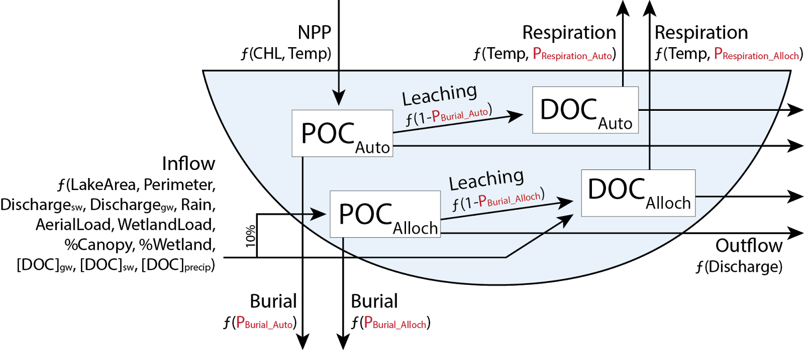

**Figure 1.**

Figure 1. Conceptual diagram of the organic carbon lake model depicting fluxes based on allocthonous (externally derived) and autochthonous (NPP) inputs of organic carbon, long-term burial, leaching of particulate organic carbon (POC) to dissolved organic carbon (DOC), respiration of DOC to CO2, and export via outflow. Four parameters (Respiration_auto, Respiration_alloch, Burial_auto, and Burial_alloch) are treated as free parameters and calibrated for each individual lake. Parameters and equations are defined in Tables 2 and 3.

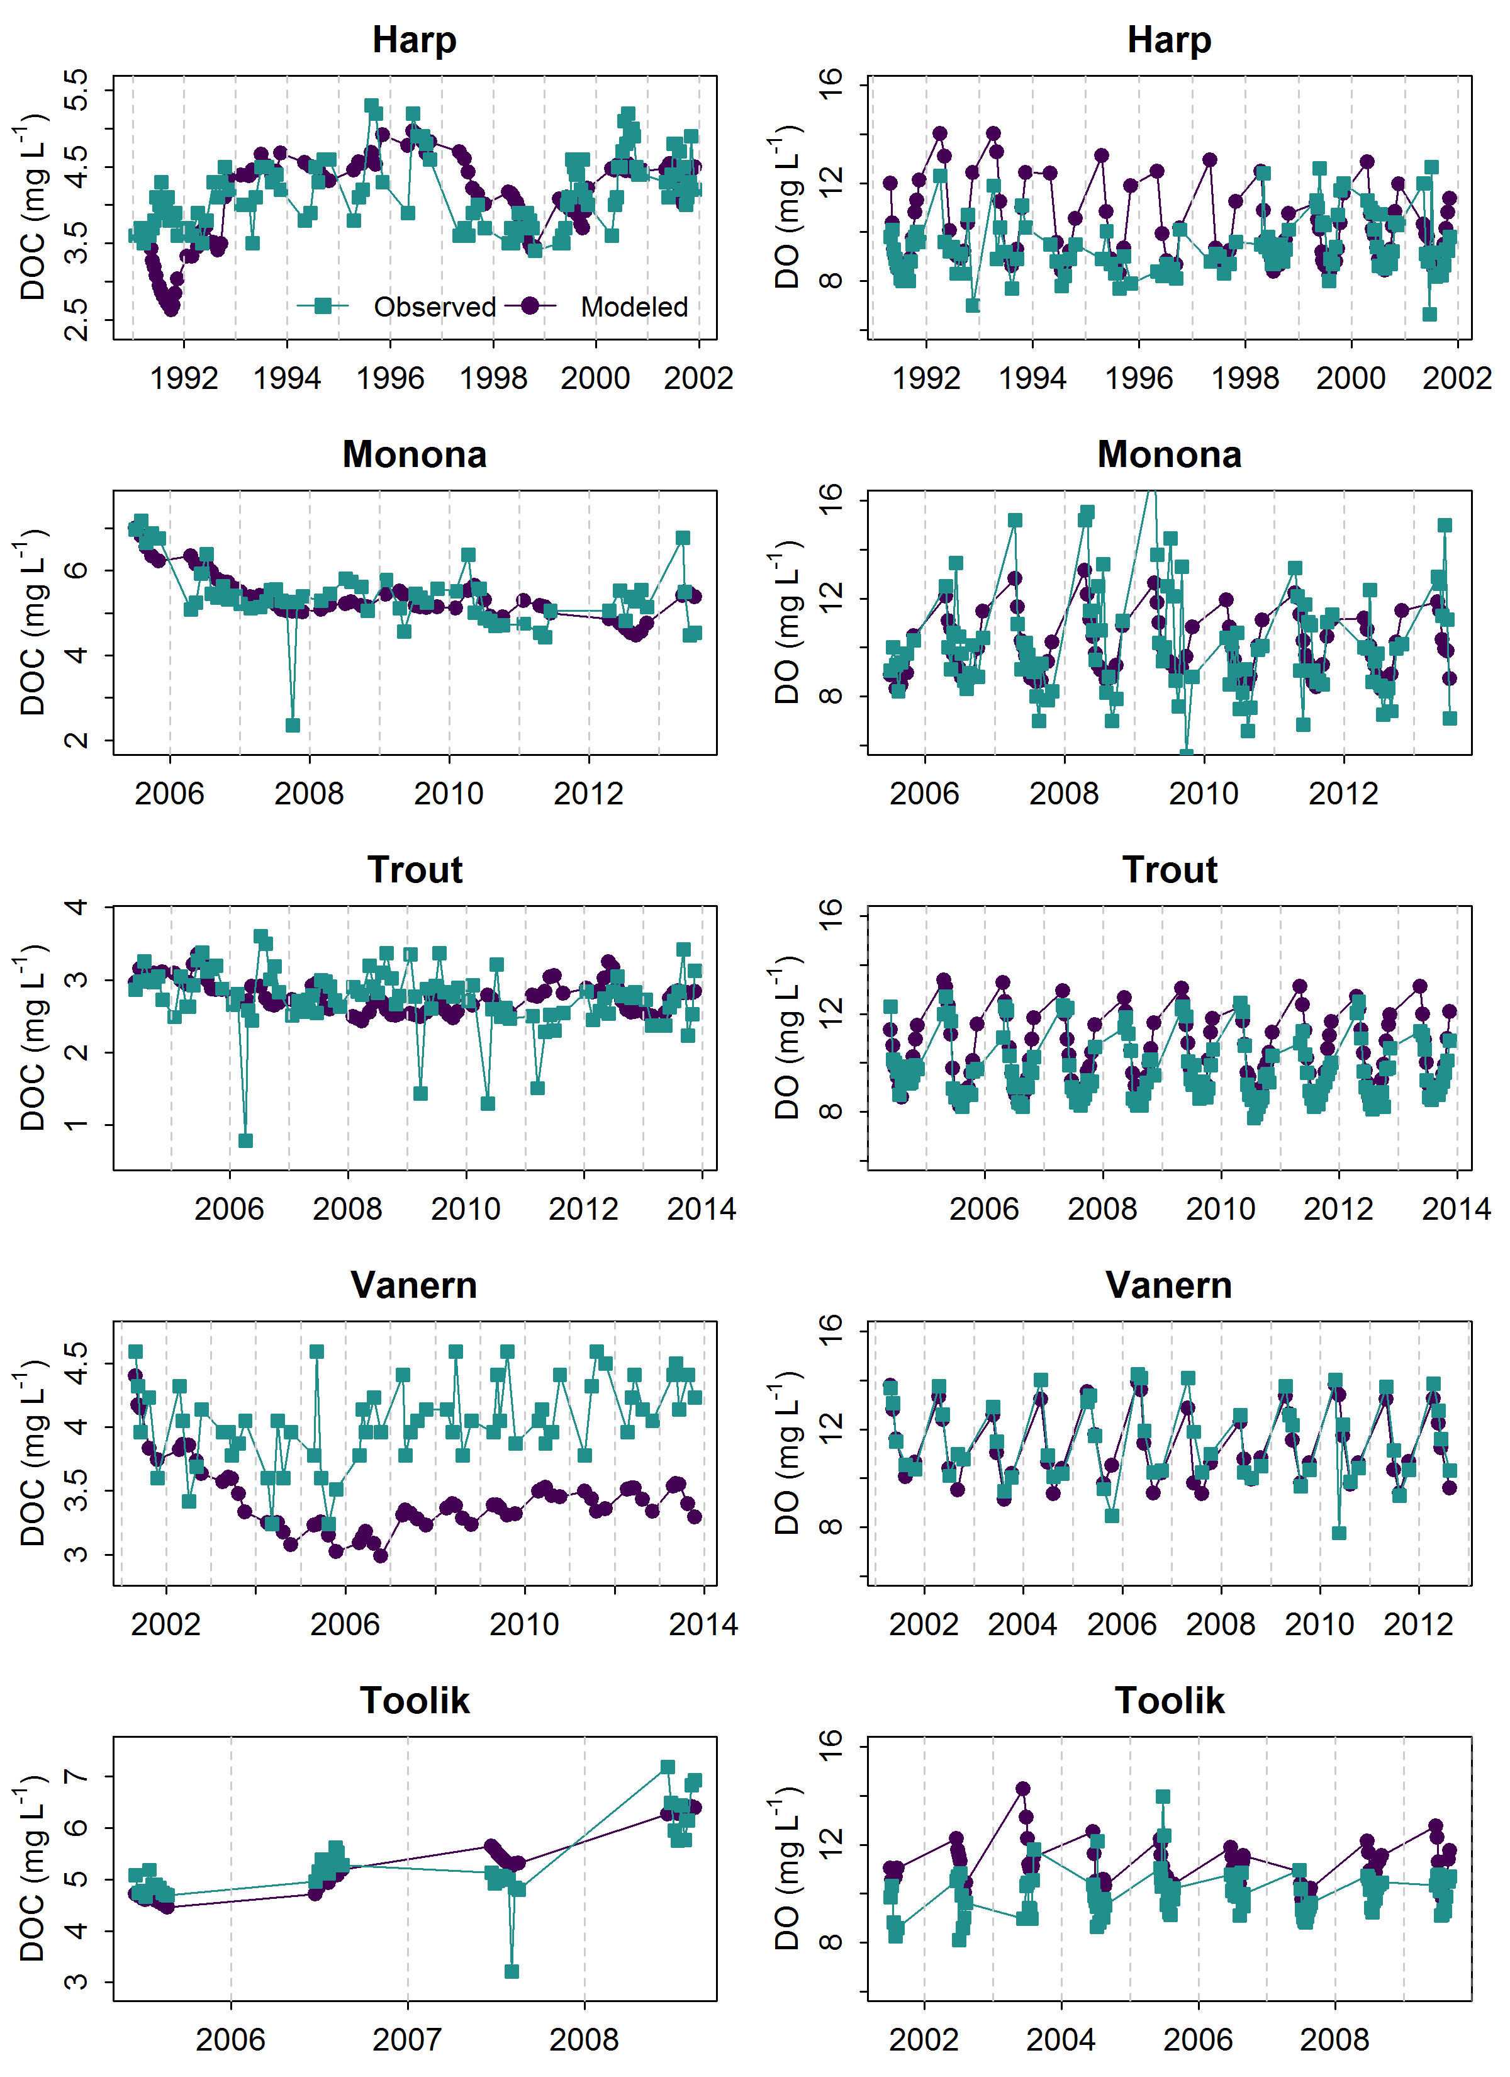

**Figure 2.**

Figure 2. Observed dissolved organic carbon (DOC) and dissolved oxygen (DO) concentrations in all lakes (blue circles) compared with modeled concentrations (red squares) on the same date. For some lakes, years differed between DOC and DO based on availability of observed data (S2).

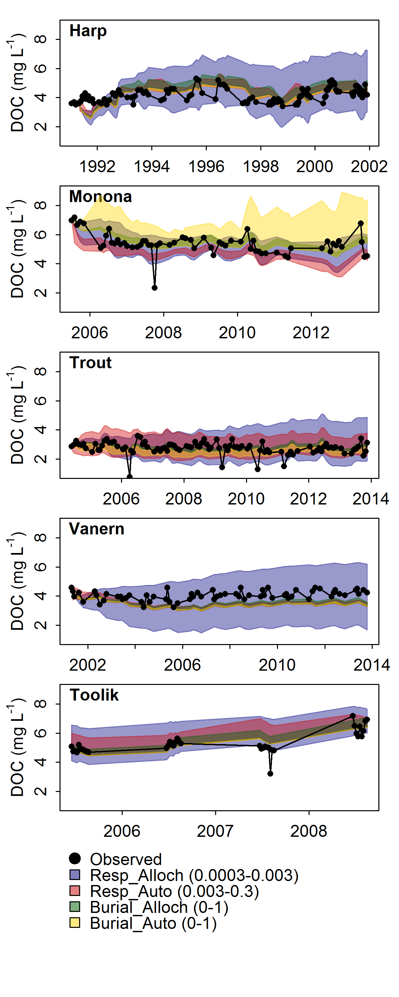

**Figure 3.**

Figure 3. Sensitivity of DOC predictions to free parameters in the model. Each parameter was varied across a given range (Resp_Alloch 0.0003-0.003, Resp_Auto 0.003-0.3, Burial_Alloch 0-1, Burial_Auto 0-1) while the other three parameters remained fixed at their calibrated values. Shaded areas represent the range of modeled dissolved organic carbon (DOC) concentrations as each parameter is varied. Black circles represent the observed in-lake DOC concentrations.

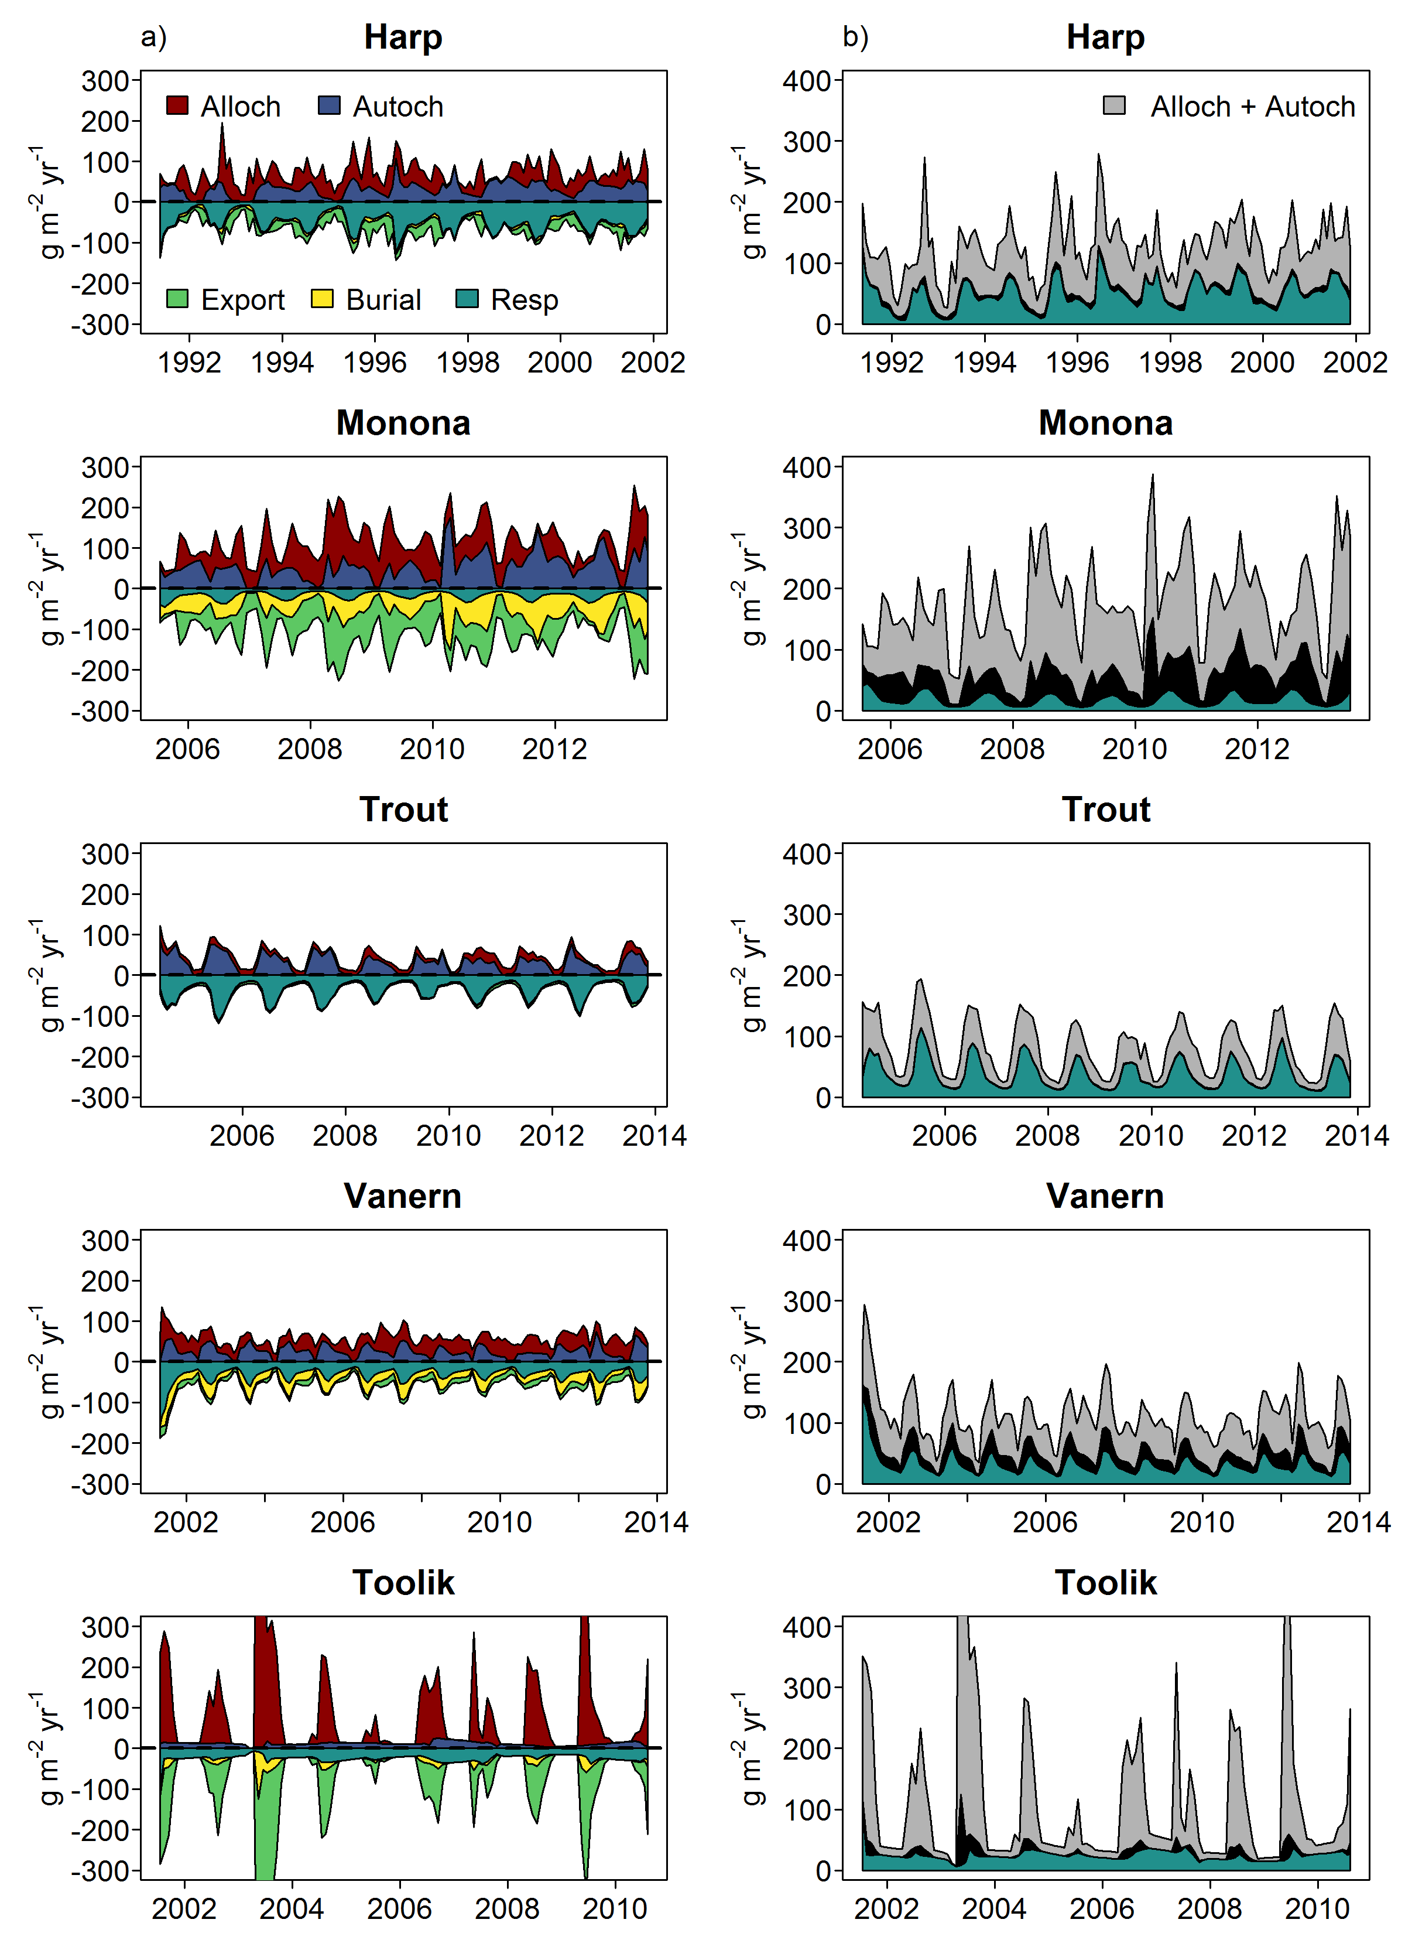

**Figure 4.**

Figure 4. Time series of organic carbon fluxes and fates. a) Colored areas represent relative magnitudes of input fluxes (allochthonous and autochthonous) and output fluxes (export, burial, and respiration). All lines are stacked to show cumulative magnitudes. b) Absolute values of burial and respiration, and input fluxes.

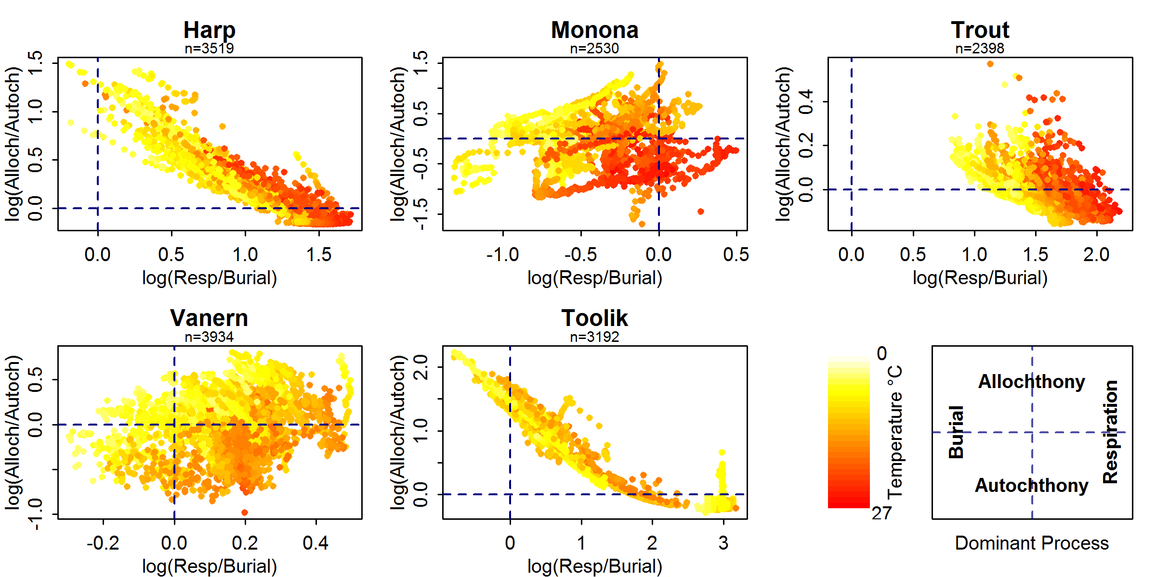

**Figure 5.**

Figure 5. Relationship between log10-transformed allochthony/autochthony and respiration/burial (g m-2 yr-1) of organic carbon, colored by epilimnion water temperature. The four quadrants in each figure represent the dominant processes (either predominantly a respiration or burial, and either predominantly allochthonous driven or autochthonous driven) associated with each lake.

1. ^ Current address: Rubenstein School of Environment and Natural Resources, University of Vermont, 81 Carrigan Dr., Burlington, VT, 05405, US.